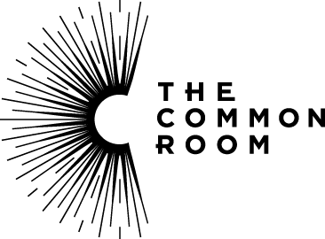

The Common Room Food & Beverage Assistant

Introduction/Background to the Role

The Common Room of the Great North Limited (CRGN) is a limited company and registered charity, created to take forward the restoration and redevelopment of its Grade 2* listed 19th Century building, Neville Hall in Westgate Road, Newcastle upon Tyne and to preserve its internationally important collection and archive.

Funded by National Lottery Heritage Fund, The Common Room reopened in July 2021 having fully refurbished the building as a hub for delivery of its charitable mission “to use our unique heritage to inspire the next generation of innovators and engineers”. It also is a heritage venue providing spaces for hire for events and also has a café bar, 5|Quarter.

Further details of The Common Room and the project can be found on our website - www.thecommonroom.org.uk

Job Summary

We are looking for confident, customer-focused, and proactive Food & Beverage Assistants to join our flexible, zero-hours team. You'll support the day to day running of our 5|Quarter café bar and event catering operations within The Common Room.

You’ll play a key role in delivering high-quality food and drink service to a wide range of customers from café visitors to private hires ensuring a professional and welcoming experience for all. All profits support our charitable activities.

Job Description

Job | Food and Beverage Assistant
Salary | National minimum wage plus tips
Duration | Zero Hours
Reports to | Head of Trading

Main Responsibilities / Activities

- Deliver excellent customer service in the 5|Quarter café bar and during event
- Handle cash and card payments accurately using the till system
- Maintain good product knowledge and respond confidently to customer queries, including allergens
- Follow all food safety and hygiene procedures
- Keep food and beverage areas clean, tidy, and well-presented
- Prepare and serve drinks, including alcoholic beverages and basic cocktails
- Monitor and restock bar inventory and supplies
- Support the external catering team as required
- Assist in menu presentation and event setup
- Ensure legal compliance (e.g. age verification for alcohol sales)
- Carry out any other reasonable duties as required around the building

All staff/freelance contractors are expected to:
- Positively support equality of opportunity and equity of treatment of colleagues in accordance with the Diversity Policy/statement.
- Help maintain a safe working environment by attending training in Health and Safety requirements as necessary and following local safe working practices and the Health and Safety Policy.

Please visit Work with us - The Common Room for full details
Person Specification

ESSENTIAL SKILLS, KNOWLEDGE AND EXPERIENCE
Bar and café experience | Experience is not essential for this role as full training will be provided
Communication and customer service skills | Experience in effective communication and excellent customer service
Organisational skills | Extremely well organised, with great attention to detail, and an ability to coordinate, timetable and balance a broad range of priorities
IT skills | Ability to use electronic till and ordering system
Personal Attributes | An interest in the heritage of the North East

Appointment and Application Details and Timetable

Role advertising 21st July 2025

Please send your CV and an email stating why you would like the job to Philippa.king-williams@thecommonroom.org.uk.

Please note that we will review applications as they come in and may offer an earlier interview for skilled candidates.

